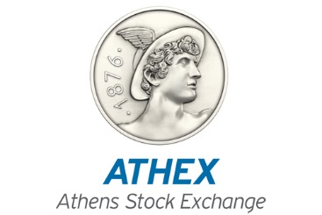

Athens, February 25th , 2016
Suspension of trading of the shares of the company
ELVAL HOLDINGS SA

Τhe Athens Exchange, following the request of the company “ELVAL HOLDINGS SA”, in light of the expected completion of the Cross Border Merger with the company “VIOHALCO SA”, announces the suspension of the trading of the shares of the aforementioned company, as of Friday, 26 February 2016, for the assurance of the smooth operation of the market.

